Making connex-ions for the over 65s
Buxton Cinema and Connex Community Support have joined forces to bring more social activities to the local communities, over 65s.
Alive and Kickin’, part of Connex Community Support (formerly known as Voluntary & Community Services Peaks & Dales) is a Comic Relief funded project designed to offer the over 65s a whole range of activities. From Our Kind of Music an afternoon club playing music from the 50s and 60s; to Stay Safe a peer-led group of older people who work with the local police to promote personal safety; and an inter-generational Board Game Group where older people teach traditional board games to primary children.
The project is now working alongside Buxton Cinema to help promote the regular Silver Screenings, showing a range of classic films such as Breakfast At Tiffany’s and more contemporary films such as A Private War. Not only can seniors enjoy the film for £5, they are also invited to stay and have a natter over tea and biscuits after the film.
Alongside the cinema screenings, Buxton Cinema and Alive and Kickin’ will also be welcoming anyone over the age of 65 to their new social events. Offering older people the chance to get out and meet new people, these socials will be the perfect antidote to that Monday afternoon feeling. Starting on Monday 25 March at 1.30pm at the Old Hall Hotel, the first event will be a film quiz. So if you think you know your Orson Welles films from your John Wayne, then this is the perfect time to test your knowledge. Entry is free and they’re even throwing in a free drink!
Buxton Cinema is keen to work with Alive and Kickin’ to provide an outlet for older people wanting to be more social. Emma Oaks, Head of Marketing & Audiences at Buxton Opera House & Pavilion Art Centre, who run Buxton Cinema said ‘We’re famous for our welcome at the Opera House, and we want to extend that to everyone who comes to Buxton Cinema. Loneliness and social isolation is a particular problem around parts of Buxton, and we hope that by working with Alive and Kickin’ we can increase the events and activities that Buxton has to offer for the over 65s.’
Colin Floyd one of the Alive and Kickin’ co-ordinators added ‘We are looking forward to working with Buxton Cinema and the Opera House. Going to the Cinema was a main social occasion for many of our clients when they were younger, and it is great that we have the opportunity to bring some of that spirit back into the lives of the people we are working with, through this project we also hope to give over 65s a chance to have their say about what films they would like to see and also to advise the Cinema and Opera House about other age related issues such as Disabled access’.
Buxton Advertiser ran the ‘Know You’re Not Alone’ campaign last year to help break the stigma around loneliness. Figures from Age UK show that over 3.6 million older people live alone in the UK, with some parts of Buxton being a particularly high risk areas for loneliness in the over 65s.

If organising is more your thing, you can help run these socials, influence what the project can offer and help promote events by getting in touch with Colin Floyd the Project Coordinator on aliveandkicking@connex.org.uk
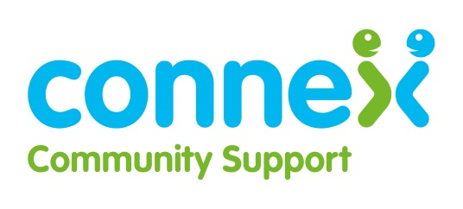
Ends
For more information about events, competition and press tickets, contact Helen Naylor, email: hnaylor@boh.org.uk or Tel: 01298 72050

