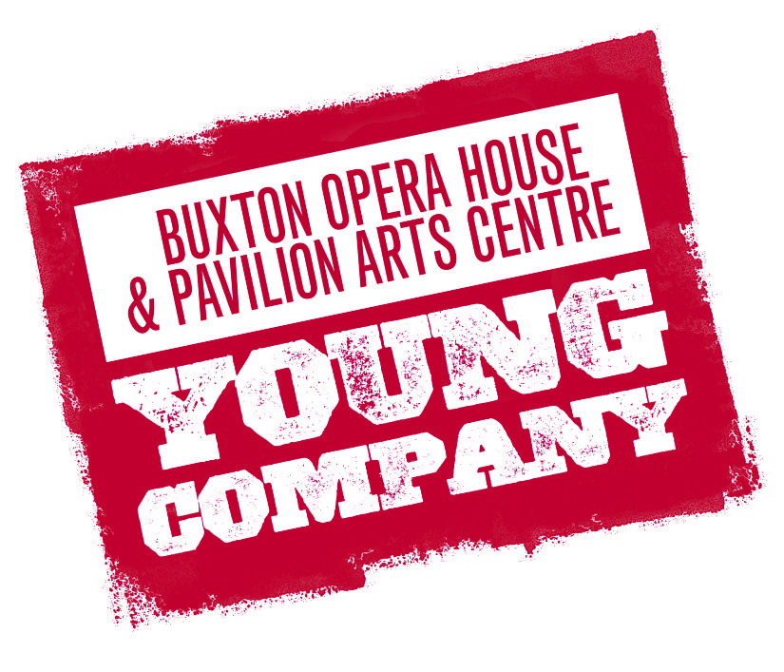
APPLICATON PACK: BOHYC 2018/19

INTRODUCTION

Thank you for taking an interest in our Young Company and taking the first step to applying to become a member. BOHYC is our flagship training programme for young theatre makers aged between 5 and 16 years. Since 2014, our Young Company has successfully mounted six productions, collaborated on projects with the National Theatre and English Touring Opera and has taken productions to other theatres including Derby Theatre and The Lowry.

BOHYC is a creative hub for young people where they can experiment, develop and fine tune their creative skills in both performance and production, in a safe and supportive environment with the full support of our professional team.

PERFORMANCE GROUPS

Young Company  (5 – 11 years)  16:00pm – 17:15pm  Pavilion Arts Centre* | Term 2 start date:  Wednesday 9 January – Wednesday 13 February (6 sessions)  Break for February half-term  Wednesday 27 February – Wednesday 10 April (7 sessions)
Young Company
(12 – 16 years)

17:30pm – 18:45pm

Pavilion Arts Centre*

*Please note: Sessions on Wednesday 30 January & Wednesday 27 February will take place on the Opera House stage.

APPLYING

Data Protection Act: The information provided on this form will only be used for the purpose of administering Young Company at High Peak Theatre Trust Ltd. The data will not be disclosed to any external sources other than in an emergency.

Applying to be a member of one of our performance groups is simple, just follow the simple steps below.

Applying to join Young Company:

- Complete the enclosed application form and send it to us.
- Give as much information as you can on why your child wants to become a member of Young Company, continue on a separate sheet if necessary.
- If we have a place available for your child, they can start at the beginning of the the term. Please note that there are only 30 spaces per group available so please send your application form back ASAP to avoid disappointment.
- When your application form has been processed we will then send you the payment details. Payment must be paid by the deadline. If the deadline is not met your child will not be able to take part in Young Company.

Application Form: BOHYC 2018/19

Please select which group you wish to apply for:
 |  | Young Company  (5 - 11 years) |  | Young Company  (12 – 16 years)

If you are applying for Young Company (12 - 16yrs), what areas are you interested in?
Performing |  | Marketing |  | Front of House |  | Directing
Writing |  | Producing |  | Stage Managing |  | Technical Theatre

APPLICANT DETAILS:
Full Name: |  |  |  |  | Age:
Address: |  |  |  | Date of Birth:
Address: |  |  |  | Post Code:
Telephone: |  | Email:
School/College

Why do you want to become a member of the Young Company performance group?

Do you have any medical conditions, allergies or disabilities we should know about? | Yes |  | No
(If you answered ‘yes’, please use this space to provide details. Including how we can help you.)

We may occasionally take photographs and videos of our Young Company which we may use for promotional purposes such as; social media, website and brochures. Please tick yes if you are happy to give your consent for this. | Yes |  | No

Emergency Contact:
Telephone: |  | Relationship:

DECLARATION
I confirm that the information provided on this for is true and correct. By signing this application form, I agree that my/my child’s participation is Young Company will be governed by the terms and conditions which I agree to abide by.
Signed: |  | Date:
Print Name:

TERMS AND CONDITIONS

Formation of Contract

The contract between High Peak Theatre Trust Ltd (Buxton Opera House) and the client comprises of a completed and signed Young Company application pack and payment of the published participation fee.

Price, Payment and Variations

Young Company fees must be paid in full before the commencement of the term via the payment method of BACS. High Peak Theatre Trust Ltd is a registered charity, and the running of Young Company depends heavily on the financial support of participation fees, since we do not receive any funding.

The fee breakdown is as follows:

Term 2 runs from January – April 2019

Young Company (5 – 11) £60 (13 workshops)
Young Company (12 – 16) £80 (13 workshops)

Fees are charged per term. Therefore fees remain unaffected when the number of sessions are variable per term as required. If you wish to join Young Company after October half-term, please contact us to discuss fees.

Conditions of Young Company

- Always register with your workshop leader, workshop assistant or warden every time you enter or leave the building.
- Always arrive in plenty of time for each workshop and rehearsal.
- Always consider the staff working in the building. Do not run or shout either inside the studios, in the corridor areas, front or backstage or in the foyer areas of the theatre.
- Do not bring in any valuable items unless you absolutely have to.
- Do not bring bicycles, scooters or skateboards in to the building.
- Always clean away all of your rubbish in the bins provided.
- Always listen to staff members and respect them when they are talking. You should not talk when you have been asked to remain quiet; you may miss some important information.
- Always tell a member of staff if you are involved in an accident.
- Always tell a member of staff if you have, or witness, any problems.
- Always switch your mobile phone off at the start of each session.
- Do not take anything from the building without permission.
- Do not eat or chew gum in workshop sessions.
- Do not smoke anywhere in or around the building.
- Do not swear at any time in or around the building.
- Do not bully physically or emotionally any member of your course.
- Always treat others as you wish to be treated yourself.

Application forms to be sent via email to skell@boh.org.uk & kallsop@boh.org.uk or by post to Learning and Engagement Department, 5 The Square, Buxton Opera House, Buxton, SK17 6AZ.

 Before you print think about the ENVIRONMENT

